Task 1: Create a custom node, add elements to it and traverse it.

Solution : 

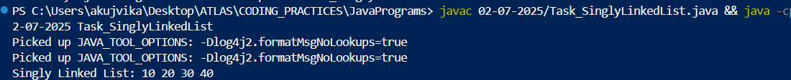

Task 2 : What do you understand by traversing elements in a linked list.

Solution : Traversing elements in a linked list means visiting each node in the list, one by one, starting from the head node and following the 'next' pointers until the end of the list (or until a certain condition is met). This process is commonly used to display, search, or process the data stored in each node.

Task 3: Create a Circular Linked list using Task 1 Singly linked list.

Solution : 



class Node {

int value;

Node nextNode;

public Node(int value) {

this.value = value;

}

}

public class CircularLinkedList {

// if the list is empty

private Node head = null;

private Node tail = null;

// …..

}

public void addNode(int value) {

Node newNode = new Node(value);

if (head == null) {

head = newNode;

} else {

tail.nextNode = newNode;

}

tail = newNode;

tail.nextNode = head;

}

private CircularLinkedList createCircularLinkedList() {

CircularLinkedList cll = new CircularLinkedList();

cll.addNode(13);

cll.addNode(7);

cll.addNode(24);

cll.addNode(1);

cll.addNode(8);

cll.addNode(37);

cll.addNode(46);

return cll;

}

public boolean containsNode(int searchValue) {

Node currentNode = head;

if (head == null) {

return false;

} else {

do {

if (currentNode.value == searchValue) {

return true;

}

currentNode = currentNode.nextNode;

} while (currentNode != head);

return false;

}

}

public void deleteNode(int valueToDelete) {

Node currentNode = head;

if (head == null) { // the list is empty

return;

}

do {

Node nextNode = currentNode.nextNode;

if (nextNode.value == valueToDelete) {

if (tail == head) { // the list has only one single element

head = null;

tail = null;

} else {

currentNode.nextNode = nextNode.nextNode;

if (head == nextNode) { //we're deleting the head

head = head.nextNode;

}

if (tail == nextNode) { //we're deleting the tail

tail = currentNode;

}

}

break;

}

currentNode = nextNode;

} while (currentNode != head);

}

Task 4 : *Stacks* : Create a code to implement a stack

Solution :

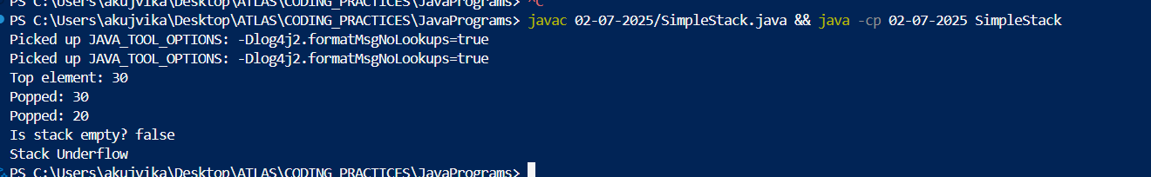

Task 5: Create a stack and pop the element also print the popped element.

import java.util.Stack;

class Ds_Stack_Pop {

public static void main(String[] args) {

Stack<String> names= new Stack<>();

names.push("Prasunamba");

names.push("Meher");

names.push(".MK");

System.out.println("before deletion ");

System.out.println("Stack of names: " + names);

System.out.println("after deletion ");

String dummy = names.pop();

System.out.println("Stack of names: " + names);

System.out.println("deleted element is "+ dummy);

}

}

Solution :



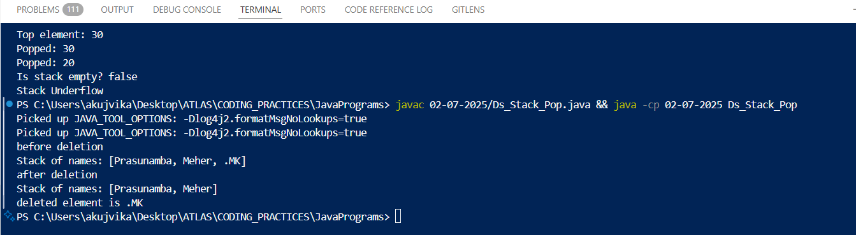

Task 6: Find an element in the stack and display the position

Hint 👍

Int position = names.search(“value”);

import java.util.Stack;

class Ds_Stack_SearchPosition {

public static void main(String[] args) {

Stack<String> names= new Stack<>();

names.push("Prasunamba");

names.push("Meher");

names.push(".MK");

System.out.println("Stack of names: " + names);

String Val = "Meher";

int position = names.search(Val);

System.out.println("the searched value is at position " + position);

}

}

Solution : 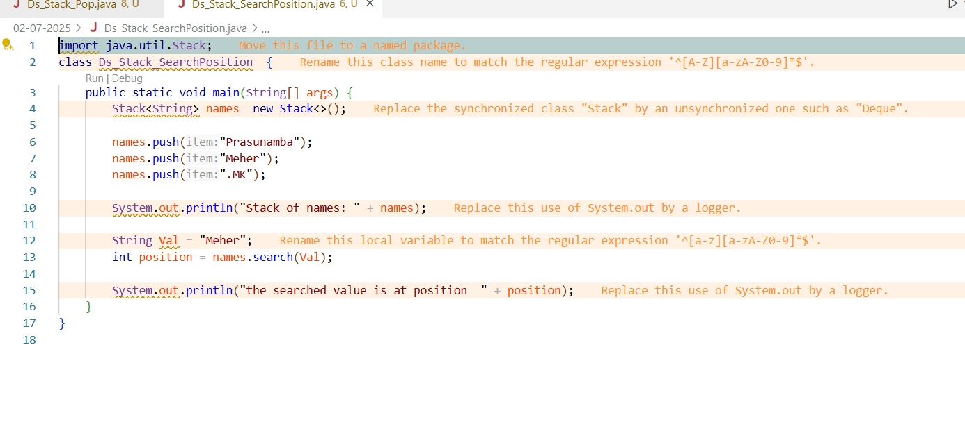



Task 7: Peek the element and print it.

import java.util.Stack;

class Ds_Stack_Peek {

public static void main(String[] args) {

Stack<String> names= new Stack<>();

names.push("Prasunamba");

names.push("Meher");

names.push(".MK");

System.out.println("Stack of names: " + names);

String topElement = names.peek();

System.out.println("The top element (without removal); "+ topElement);

System.out.println("Stack of names after peek operation " + names);

}

}

Solution :

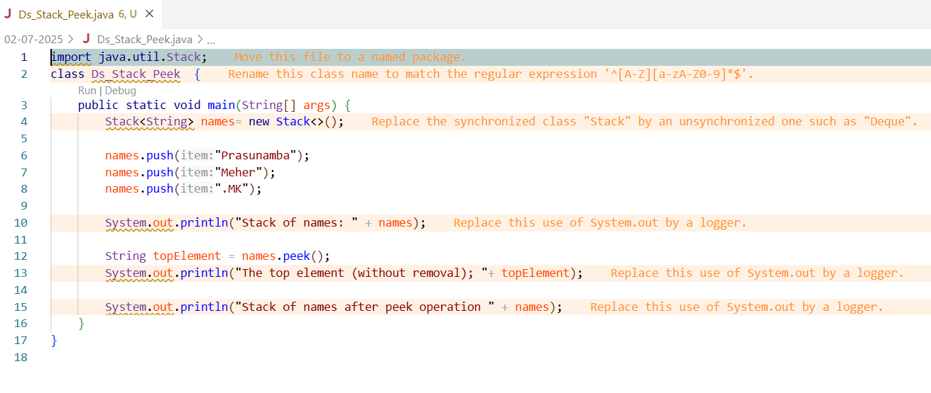



Task 8: Check if the stack is empty or not?

import java.util.Stack;

public class Ds_Stack_Empty {

public static void main(String[] args) {

Stack<String> names = new Stack<>();

System.out.println("Is the stack empty? " + names.empty());

names.push("Prasunamba");

names.push("Meher");

System.out.println("Is the stack empty? " + names.empty());

while (!names.empty()){

System.out.println("Popped: " + names.pop());

}

System.out.println("Is the stack empty? " + names.empty());

}

}

 

Task 9: What are the methods of the stack class

Solutions :

Below methods allow you to use the stack as a Last-In-First-Out (LIFO) data structure.The main methods of the Java Stack class are:

push(E item): Adds an item to the top of the stack.

pop(): Removes and returns the top item from the stack.

peek(): Returns the top item without removing it.

empty(): Checks if the stack is empty (returns true or false).

search(Object o): Returns the 1-based position of an object from the top of the stack (or -1 if not found).

Queues

Task 10: What are the common operations in Queues

Solution : Below operations make queues a First-In-First-Out (FIFO) data structure. The common operations in queues are:

Enqueue: Add an element to the end (rear) of the queue.

Dequeue: Remove and return the element from the front of the queue.

Peek / Front: View the element at the front without removing it.

isEmpty: Check if the queue is empty.

isFull: (For fixed-size queues) Check if the queue is full.

Size: Get the number of elements in the queue.

Task 11: Wap to create a queue with custom methods

Is empty ()

Is full()

Enque

Deque

Peek

display()

Solution :

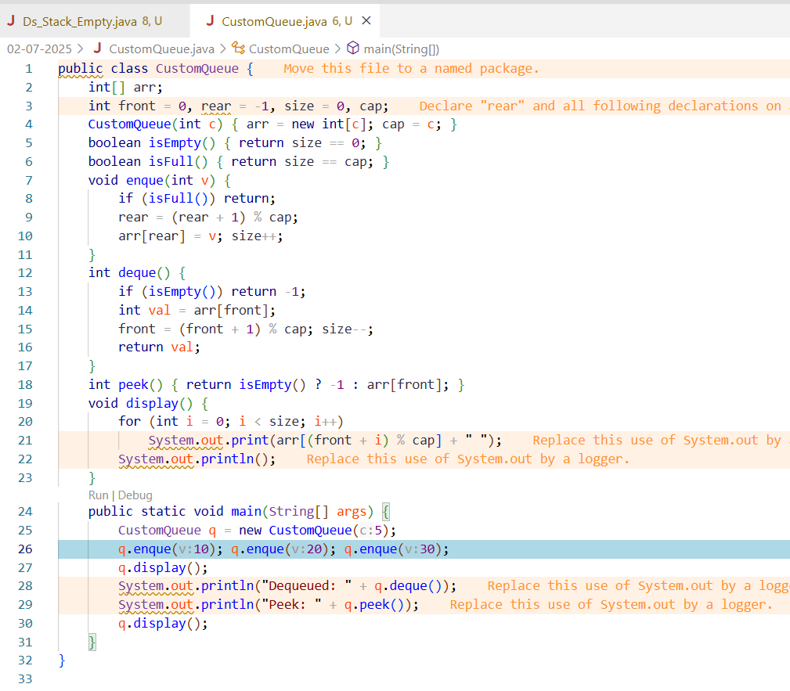



Home Tasks:

Recursion:

Wap to find the factorial of a number

Wap to find the Fibonacci series of a number

What is the difference between recursion and iteration

Wap to reverse a string using recursion..

Carry forward examples till 10 th july

Write a recursive function to search for an element in an array

2. Write a recursive function to count the digits of a positive integer (do also for sum of digits)

3. Write a recursive function to reverse a null-terminated string

4. Write a recursive function to convert a decimal number to binary

5. Write a recursive function to check if a string is a palindrome or not

6. Write a recursive function to copy one array to another